D.0 Reversal for B2 and B3 Transaction

This document does not include all existing 5.1 functionality or back out logic performed today. All of the existing 5.1 logic should continue with the exception of any business requirements noted below and in the Claim Billing Transaction Translation Rules document.

Request and Response Segments
The following Request and Response segments are used for processing reversals. See the Claim Billing Transaction Translation Rules document for detailed business requirements and data validation rules for the request and response segments.

The reversal program must populate the response segments and fields within the segment depending on the outcome of the reversal request. (The translation program formats the response based on the fields populated by the reversal program.) See Claim Billing Translation Business Rules document for more details.

Request Segment
Request Segments | Mandatory  Or  Optional
Header | Mandatory
Insurance (new) | Optional
Claim | Mandatory
Pricing (new) | Optional
COB (new) | Optional
DUR/PPS | Optional

Response Segment
Response Segments | Transmission Accepted/Transaction Approved (A/A) | Transmission Accepted/Transaction Rejected (A/R) | Transmission Rejected/Transaction Rejected (R/R)
Header | Mandatory | Mandatory | Mandatory
Message | Optional | Optional | Optional
Status | Mandatory | Mandatory | Mandatory
Claim | Mandatory | Mandatory | Mandatory
Pricing | Optional | Not Used | Not Used

Claim Reversals for Multiple Members
Although the standard supports reversals for multiple members on the same transaction, NCPDP strongly recommends that this not be supported.

From Section 10 Reversal Information in the Telecommunication Standard Implementation Guide, NCPDP states; “Multiple claim or service reversal transactions in a transmission must be for the same patient.” Argus chooses not to enforce this, but instead relies on the pharmacies to submit multiple reversals in a single transmission for the same member.

Find the Claim to Reverse
Current 5.1 Matching Logic
The claim to reverse must be a paid POS claim and must match the following submitted data: Service Provider ID (AKA Pharmacy) (201-B1), Prescription Service Reference Number (AKA Rx Number) (402-D2), Date of Service (401-D1), Product Service ID (AKA NDC) (407-D7). (Note: NDC does not have to match for B3 reversal part of the rebill, only for B2 reversals).

- Search POSTRN file first.
- If matching claim is not found on POSTRN, then read table MIPCT061 to see how many days back the customer allows reversal of claims. Fill date on claim must be within the number of days specified on the table.
- Read claim file to find a matching claim.

D.0 Matching Logic
The claim to reverse must be a paid claim and must match the following submitted data: Service Provider ID (AKA Pharmacy) (201-B1), Prescription Service Reference Number (AKA Rx Number) (402-D2), Date of Service (401-D1), Product Service ID (AKA NDC) (407-D7) and Product Service ID Qualifier (AKA NDC Qualifier) (436-E1). In 5.1, the NDC qualifier was not used in matching logic. For D.0, NDC qualifier must be used in matching logic. Note: NDC and NDC Qualifier do not have to match for B3 reversal part of the rebill, only for B2 reversals.

- Search POSTRN file first.
- If matching claim is not found on POSTRN, then read table MIPCT061 to see how many days back the customer allows reversal of claims. Fill date on claim must be within the number of days specified on the table.
- Read claim file to find a matching claim.

If there are multiple claims on the same day matching the reversal request, the field Fill Number (403-D3), on the request must match the value on the claim to be reversed. Fill Number is ignored if there is only one claim. Note: Multiple refers to multiple COB claims or multiple non COB claims and not 1 COB and 1 non COB. The COB segment is used for tiebreaker in this situation.

Reversal Claim Scenarios (Allowed/Rejected)
5.1 Logic
The existing 5.1 logic does not check for a COB segment when reversing a 5.1 COB claim. During the migration period; COB matching logic will not be enforced for a D.0 COB claim reversal to reverse a 5.1 COB claim.

D.0 Logic
The COB segment is required on the D.0 claim reversal request when reversing a D.0 COB claim. COB matching logic will only be enforced for a D.0 COB claim reversal to reverse a D.0 COB claim.

Note from Cherri: There is still some confusion on if this is ‘must’ or only ‘required if needed’. Should have a definite answer after they do the COB webinar thingy.

Claim Reversals (Allowed/Rejected)
 | COB Claim | Primary Claim
COB Reversal | Claim reversal allowed | Claim reversal rejected
Primary Reversal | Claim reversal rejected | Claim reversal allowed

Claim Reversal (submitted with COB segment) - Single COB Claim Found
If COB segment is submitted, only a COB claim can be reversed. If COB segment is not submitted, a COB claim cannot be reversed.

Claim Reversal (submitted with COB segment) - Multiple COB Claims Found
A COB claim reversal is only allowed when the COB segment is submitted. Otherwise, if the COB segment is not submitted then the COB claim reversal cannot be reversed.

The field Other Payer Coverage Type (338-5C) is used to match the COB reversal request to the COB claim. This field can occur in any order. Match the highest value Other Payer Coverage Type on the reversal request to the highest submitted value on the claim. For example, if reversal request has field Coordination of Benefits/Other Payments Count (337-4C) = “2” and two occurrences of field Other Payer Coverage Type (338-5C) with values of “1” and “2”, in any order, the highest value is “2” (secondary). Since the reversal Other Payer Coverage “2” is the highest value then select claim that has a “2” as the highest submitted value in the Other Payer Coverage Type field.

Claim Reversal (submitted with no COB segment) - Single COB Claim Found
If COB segment is not submitted, a COB claim cannot be reversed so the claim reversal will be rejected.

Claim Reversal (submitted with no COB segment) - Multiple COB Claims Found
If COB segment is not submitted, a COB claim cannot be reversed so the claim reversal will be rejected.

Claim Reversal (submitted with COB segment) – Primary Claim Found
A claim reversal submitted with a COB segment cannot reverse a primary claim with no COB segment. If COB segment is submitted, only a COB claim can be reversed.

Claim Reversal (submitted with no COB segment) – Primary Claim Found
A Primary reversal submitted with no COB segment can reverse a primary claim only with no COB segment.

Fields Used by Segment
Header Segment

5.1 Logic
Processor Control Number (104-A4)
The existing 5.1 Logic just used the customer number to determine which claim file and POSTRAN file to read. The customer number was not used in the claim selection logic.

The NCPDP standard for 5.1 did not require a customer number. If customer number was not submitted, all 4 POSTRN files were read until a matching claim to reverse was found. The claim file was not searched when claim was not found in POSTRN. There are 40 or 50 claim files, and without customer number, we wouldn’t know which one to read. Since customer number is required for D.0, only that customer’s POSTRN file needs to be read. We could cut down and only read the POSTRN that the associated customer(s) live in, or if DB2, however the associated customer field works.

Service Provider Id Qualifier (202-B2)
For 5.1, two different values “01” (NPI) and “07” (NCPDP #) were allowed. The MIPCT070 cutoff table was used to determine which qualifier was valid for the Date of Service (Date of Fill).

D.0
Processor Control Number (104-A4)
The field must be submitted with a valid Argus customer. The submitted customer number does need to match the customer number (or one of its associated customer numbers) that the claim to be reversed actually paid under. (Must match customer number according to Argus read across customer rules. Reversals submitted for customer 319 should be able to reverse a matching claim under either 319 or 320, etc.)

Service Provider Id Qualifier (202-B2)
Claim billing transaction will only accept NPI qualifier of ‘01’ for D.0. Translation program will handle this edit.

The crosswalk to NCPDP number must still be performed, since NCPDP number is used throughout claims processing. When reversing old claim that was submitted with NCPDP number, it must match on the crossed walked values to determine the correct pharmacy. (So if B1 was submitted with NCPDP number, and B2 is submitted with NPI, must still know they are the same pharmacy and match accordingly.)

Logic for pharmacy cut off table, MIPCT070, can be removed.

Insurance Segment
5.1 Logic
The Insurance segment was not used for 5.1 claim reversals.

D.0 Logic
The use of the Insurance Segment for reversal transactions is new to D.0. If submitted, it must pass all of the B2 rules in the Claim Billing Transaction Translation Rules document. It is not used to process the reversal. (The submitted cardholder id for the reversal does not have to match the submitted cardholder id on the matching B1 claim. At least for today, it does not.) Note: segment will be ignored by the B2 program.

Claim Segment
5.1 Logic
Product/Service Id Qualifier (436-E1)
This field was not used.

Fill Number (403-D3)
This field was not used for 5.1 claim reversals.

Other Coverage Code (308-C8)
This field was not used for 5.1 reversals.

D.0 Logic
Product/Service Id Qualifier (436-E1)
The submitted value on the claim reversal must match the value on the B1 claim to be reversed. On the B3 claim reversal it does not have to match.

Fill Number (403-D3)
This field is required for D.0 reversals when there are multiple B1’s for the same day.

Other Coverage Code (308-C8)
Although not used to process the claim reversal, Other Coverage Code (308-C8) with a value of ‘2’, ‘3’, ‘4’, or ‘8’, is required if COB segment is submitted. This edit is handled upfront by the translation program.

Pricing Segment
5.1 Logic
This pricing segment was not used for 5.1.

D.0 Logic
The use of the Pricing Segment for reversal transactions is new to D.0. The Pricing Segment is used for contractual pricing to the pharmacy for reversals. There is not a current Argus business need for the Pricing Segment contractual pricing at this time. It could be used in the future.

If submitted, the Pricing Segment must pass all of the B2 business rules in the Claim Billing Transaction Translation Rules document.

If the Pricing Segment is submitted, the Pricing Segment must be returned in the Accepted/Accepted response. Only two fields are valid in the response. The two fields are Incentive Amount Paid (521-FL) and Total Amount Paid (509-F9). Both response fields must be populated with zero until Argus acquires a business need to pay the pharmacy for reversals.

DUR/PPS Segment
5.1 Logic
No real changes from 5.1 to D.0. The main thing to consider is that D.0 has a place to save the input DUR data and the output DUR data. If the B1 submits DUR data, and the B2 submits different DUR data, I think the original B1 DUR data is overlaid, just as it is today.

D.0 Logic
Same as 5.1

COB/Other Payments Segment
5.1 Logic
COB segment was not used for 5.1 reversals.

D.0 Logic
It must be used for D.0 reversals when reversing a COB claim. Field Other Payer Coverage Type (338-5C) is used to match the reversal request to the B1 claim when the processor processes two different plans for the same member.

Reversal Processed Nightly
5.1 Logic
When Argus acquires new business, there is a certain period of time where Argus receives the reversal request, but the old processor has the claim to be reversed. When we cannot find the claim to reverse, we reject the reversal and then write the information to a file. The file is processed nightly, and the information sent to the previous processor, so they can reverse the claim.
D.0 Logic
All of the existing 5.1 code above can be removed except for a model piece of code commented out to be used by the next new customer.

The Business Owner for the HIPAA II project has approval from most of the customers to do this. (If a new customer is added by the time you work on this, leave the new customer logic in.) One example of the code is paragraph 1392-WRITE-CAREF-REVERSAL.

Return Duplicate Response
5.1 Logic
Although we really should start returning the duplicate response, Argus has decided to not do it. It is not new for D.0, and we did not implement it with 5.1, so we won’t do it for D.0. The overhead to identify a duplicate reversal is probably not worth the effort.

There is a piece of code for art 65485 that rejects the reversal if claim already has error 74 on it. It rejects and does not return duplicate response. This logic should continue to reject these transactions and not try to send the duplicate response.

D.0 Logic
The D.0 logic remains the same as 5.1. Duplicate response will not be supported.

Remove Existing 5.1 Logic/Code
Voucher Reversal, PERFORM 1790-UPDATE-VOUCHER, can be removed.
Value Card Reversal, PERFORM 1795-UPDATE-VALUE-CARD, can be removed.
Reverse TA amount, 4500-UNDO-TA, can be removed.
Remove obsolete alternate business flag values.
Undo SUR Processing, 4300-REVERSE-SUR-HISTORY, should be moved to the S2 program.
Remove the Dual Member processing logic with the exception of customer specific logic.
Did not notice any changes on the Free Form messages, but let us know if you find any

Multi Ingredient Compound (MIC) Reversals
5.1 Logic
In 5.1, reversals of compound claims do not have to match on NDC (Argus internal field – P147A002-NDC). Note to programmer: looks like this was done when reading the POSTRN, but not when reading the claim record.

D.0 Logic
Product/Service ID Qualifier (436-E1) must be submitted with ‘00’ and Product/Service ID (407-D7) must be ‘0’ both fields must match the claim to be reversed.

Note to Programmer: MIC logic is still populating the most expensive active NDC on the NDC field on the claim record, so may not be able to match NDC to NDC on reversals. If Product/Service ID field is still zero, and if D.0 reversal logic changed to match on Product/Service ID instead of NDC, then MIC could match on Product/Service ID Qualifier and Product/Service ID. Dave, let us know what we should do.

Manual Reversal (MIPGUI97)
5.1 Logic
When performing a manual reversal, either through GUI or 3270, an internal POSTRN and POSIOZ records are created as an audit trail for that reversal transaction. 5.1 logic writes a 5.1 formatted transaction data stream to POSIOZ and 5.1 information to the POSTRN record. See paragraph: 4300- ADD-POSIOZ

The data from the 5.1 POSTRN and POSIOZ records are displayed in the following 3270 screens (LP91, LP83, LP94).

LP91 CLAIMPOS
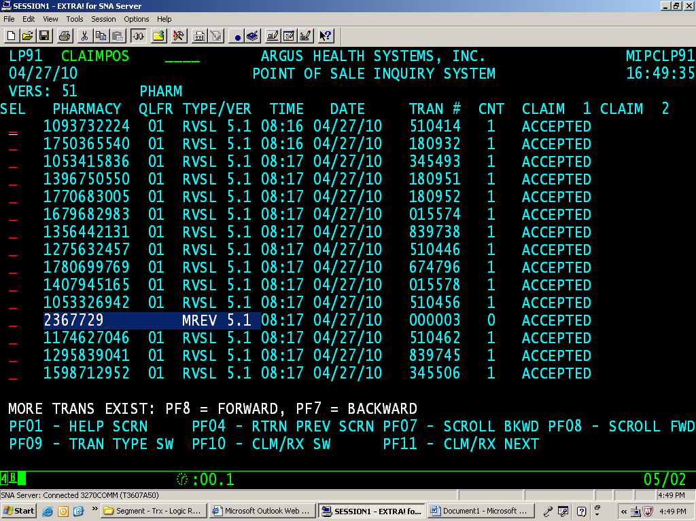

LP83 CLAIMPOS
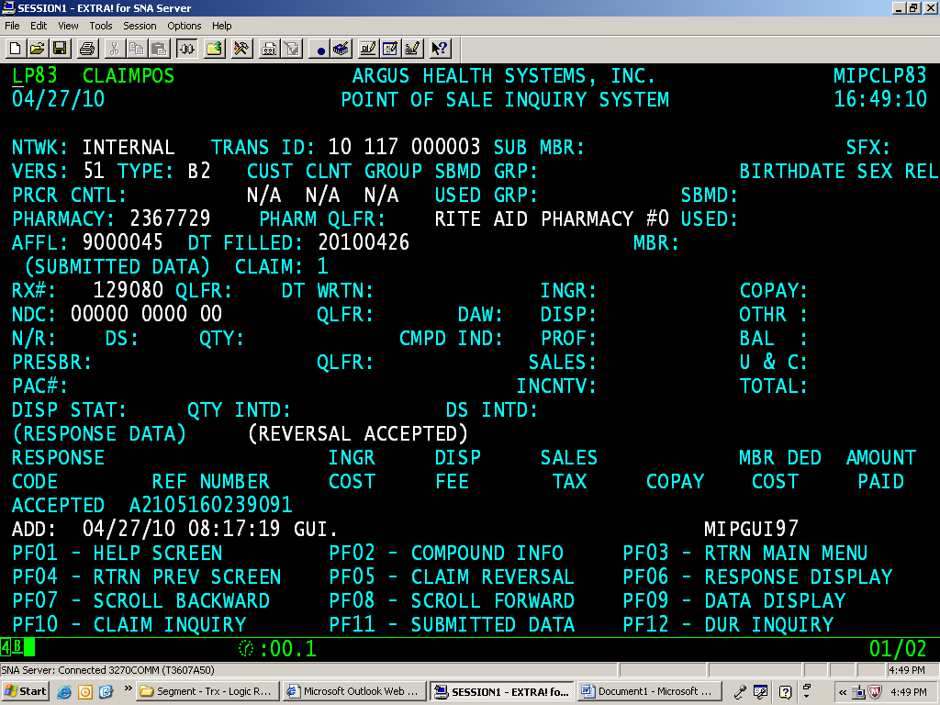

LP94 CLAIMPOS
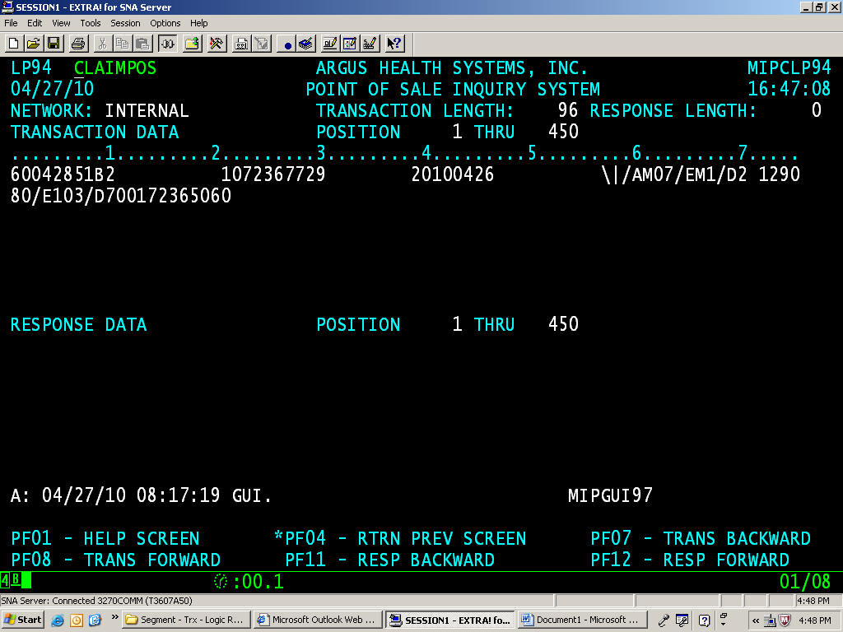

D.0 Logic
When creating the POSTRN and POSIOZ records for manual reversal, D.0 logic should create an internal D.0 formatted transaction, using the D.0 B2 translation rules.

Notable changes for POSIOZ are:

Header Segment
- Version/Release Number (102-A2) – value is ‘D0’
- Processor Control (104-A4) – value is 4 byte customer number, followed by 4 zeroes, followed by 2 spaces
- Service Provider ID Qualifier (202-B2) – value is ‘01’ for NPI
- Service Provider ID (201-B1) – value is the 10 digit NPI number

Claim Segment
- Fill Number (403-D3) – value from claim record, when known
- Other Coverage Code (308-C8) – value from claim when claim is a COB claim

COB Segment – must be used when COB claim is reversed
- COB/Other Payments Count (337-4C) – value from claim when claim is a COB claim
- Other Payer Coverage Type (338-5C) – value(s) from claim when claim is a COB claim

The following segments will not be used:
- Insurance
- Pricing
- DUR

The data from the manual reversal transaction will be displayed on these 3270 screens (LP91, LP83, and LP94).

LP91 CLAIMPOS
D.0 Business Rules:
Field VERS:
Populate this field with D.0
Field PHARMACY
Populate this field with NPI when Service Provider ID Qualifier = 01
Populate both the NPI and the NCPDP # everywhere else

Field Type/VER
Populate with MREV D.0

LP83 CLAIMPOS
D.0 Business Rules:
Field VERS:
Populate this field with D.0

Field PHARMACY
Populate this field with NPI when Service Provider ID Qualifier = 01
Populate both the NPI and the NCPDP # everywhere else

LP94 CLAIMPOS

D.0 Business Rules:

Follow B2 rules using information from B1 claim.
Populate all of the transaction data from position 1 to 450 as appropriate for D.0
Populate the VER with D.0
Transaction Type with B2
Populate the Service Provider ID with NPI if Service Provider ID Qualifier = “01”
Populate all COB and Other Coverage Type Code for COB claims.
Populate Fill Number when known
Skip the following segments: Insurance, Pricing, DUR

